ARE YOU AWARE OF YOUR 403(b) BENEFIT?
THE OPPORTUNITY
You have the opportunity to save for retirement by participating in your Employer’s 403(b) retirement plan. A 403(b) plan is a retirement plan for certain employees of public schools, tax-exempt organizations and ministries. We recommend that all employees visit our education page which can be found here: https://www.omni403b.com/Employees/Education

WHY SAVE WITH 403(b)?
- You do not pay income tax on allowable contributions until you begin making withdrawals from the plan, usually after your retirement.
- Pre-tax investment gains in the plan are not taxed until distribution and eligible ROTH investment gains are tax free.
- Generally, retirement assets can be carried from one employer to another.

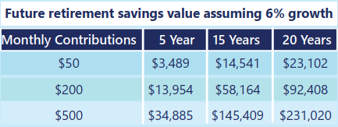

HOW CAN I PARTICIPATE?
Prior to contributing you must open an account with an investment provider authorized in the Plan, a list of which is available on the right. You may then complete a Salary Reduction Agreement (SRA) online at: https://www.omni403b.com/SRA
If you are already contributing to your Employer’s Plan and you want to change your contribution amount or investment provider, simply complete and submit a new SRA. Once we are in receipt of the newly completed SRA, we will notify your employer to begin contributions.

HOW MUCH CAN I CONTRIBUTE ANNUALLY?
In 2025, you may contribute up to $23,500 if you are 49 years of age or below and up to $31,000 if you are 50 years of age and over. You may also be entitled to additional catch-up provisions like the 15 Year Service Catch-up. Please contact OMNI’s Customer Care Center at 877-544-6664 for further details.

